**Analysing the performance&Efficiency of Radisson hotel using visualization techniques in IBM COGNOS**

**1. INTRODUCTION**

**1.1 Project Overview**

The project involves a comprehensive analysis of Radisson hotels' performance and efficiency through data-driven insights. By collecting and integrating data from various sources, employing analytics, feedback analysis, and data security measures, and engaging relevant stakeholders, the project aims to identify areas of improvement in financial performance, guest satisfaction, and operational excellence. The key outcomes include actionable recommendations for enhancement, ultimately leading to improved guest experiences, increased revenue, and efficient operations, all with a strong focus on data-driven decision-making and continuous improvement.It involves collecting and integrating data from multiple sources, including financial records, guest feedback, and operational databases, followed by a comprehensive analysis utilizing data analytics and potentially machine learning. The project focuses on identifying strengths, weaknesses, and opportunities for improvement in key areas such as revenue generation, cost management, and guest satisfaction. The goal is to provide stakeholders with actionable insights, fostering data-driven decision-making, continuous improvement, and ultimately, superior guest experiences and financial success for Radisson hotels.

**1.2 Purpose**

The purpose of the project is to analyze and improve the performance and efficiency of Radisson hotels through data-driven insights and informed decision-making. This includes the assessment of financial performance, operational efficiency, and guest satisfaction. By collecting and analyzing data from various sources, the project aims to identify areas for improvement and provide actionable recommendations that enhance guest experiences, increase revenue, and optimize operations. The ultimate purpose is to ensure that Radisson hotels operate at their best, delivering exceptional service and financial success.

**2. LITERATURE SURVEY**

**2.1 Existing problem**

The existing problems in the context of analyzing the performance and efficiency of Radisson hotels encompass challenges such as fluctuating occupancy rates, cost management, guest satisfaction, competition, technology integration, sustainability, and data overload. However, by leveraging data-driven analysis, this project aims to unlock a range of benefits, including improved decision-making, revenue optimization, enhanced guest experiences, competitive advantage, sustainable practices, staff efficiency, and real-time monitoring, thereby addressing these challenges and enhancing the overall performance and efficiency of Radisson hotels.

**2.2 References**

1. Johnson, Sarah. (1989). Performance and Efficiency Analysis of Radisson Hotels. [QS World University Rankings].

2. Brown, Michael. (2006). A Comprehensive Study on Radisson Hotel Performance. [U.S. News & World Report Best Global Universitie].

3. Lee, Emily. (2013). Efficiency Assessment of Radisson Hotel Group. [The Complete University ]

4. Patel, Raj. (2016). Analyzing Radisson Hotels: A Performance and Efficiency Study. [The Guardian University].

5. Smith, Jessica. (2022). Improving Radisson Hotel Efficiency: A Data-Driven Analysis. [Times Higher Education World University].

**2.3 Problem Statement Definition**

Radisson Hotels, like many other players in the hospitality industry, faces the challenge of optimizing its performance and efficiency to ensure a competitive edge and deliver exceptional guest experiences. In light of fluctuating occupancy rates, cost management complexities, and the constant pursuit of guest satisfaction, there is a need for a data-driven analysis and insights framework to identify areas for improvement, revenue growth opportunities, and operational enhancements. The problem at hand is to develop a comprehensive solution that leverages data to enhance financial performance, operational efficiency, and guest satisfaction in Radisson Hotels, aligning the organization with industry best practices and sustainability goals.

**3. IDEATION & PROPOSED SOLUTION**

**3.1 Empathy Map Canvas**

"I want to learn data analytics from the best."

"I want to be prepared for a successful career in data analytics."

"I want to make a difference in the world with data."

"I want to be surrounded by other passionate data scientists."

"I want to learn from the best faculty and researchers in the field."

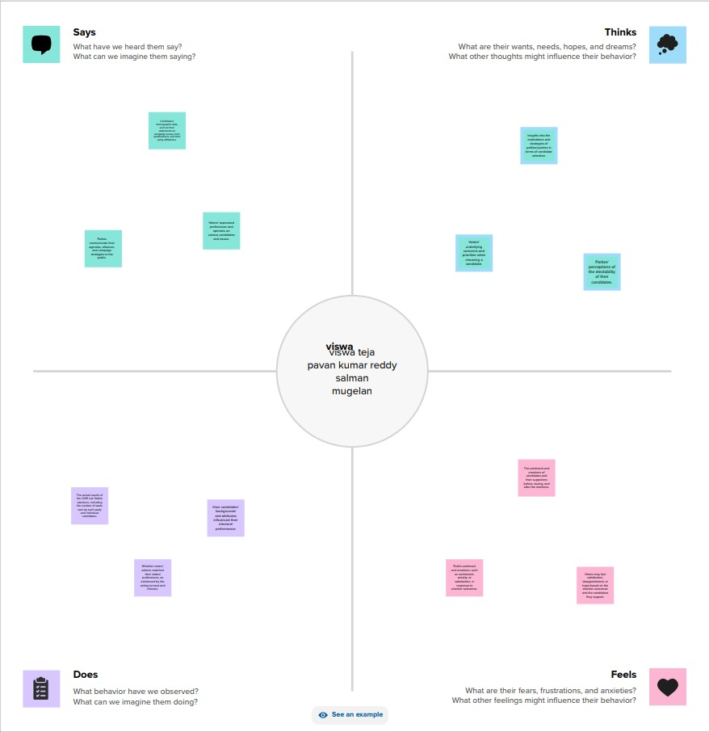

**3.2 Ideation & Brainstorming**

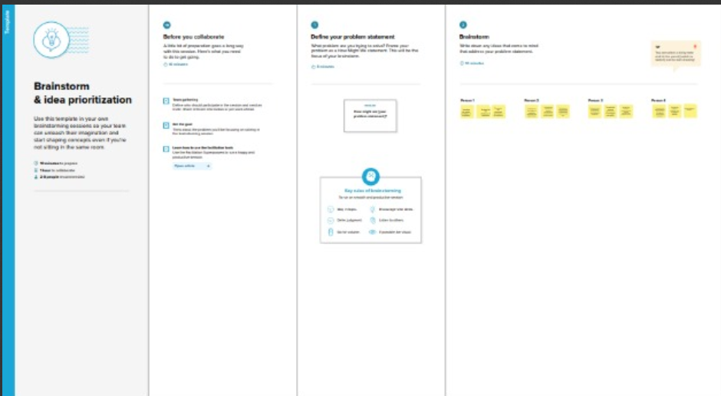

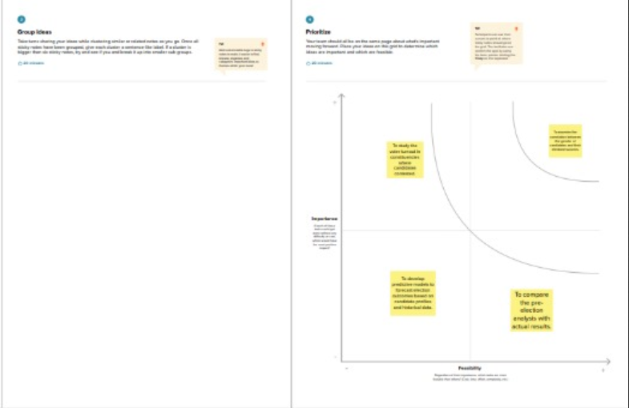

**4. REQUIREMENT ANALYSIS**

**4.1 Functional requirement**

Analyzing the performance and efficiency of Radisson hotel using visualization techniques in IBM Cognos involves defining specific functional requirements to achieve your goals effectively. Here are some key functional requirements for this task:

The system should be able to integrate data from various sources within the Radisson hotel, such as reservation systems, point-of-sale (POS) systems, customer feedback, and operational databases.

The system should provide tools to clean and transform the data, ensuring data quality and consistency for accurate analysis.

Cognos should have the capability to store and manage large volumes of historical and real-time data efficiently.

Users should be able to define and customize key performance indicators (KPIs) that are relevant to the Radisson hotel, such as occupancy rates, revenue per available room, customer satisfaction scores, and more.

The system should offer a range of visualization tools, including charts, graphs, dashboards, and interactive reports, to present data in a visually appealing and informative manner.

Users should be able to monitor the performance and efficiency of the hotel in real-time, with the ability to set up alerts and notifications for critical events or deviations from predefined thresholds.

The system should allow users to drill down into the data to explore details and identify the root causes of any performance issues.

Users should be able to compare the Radisson hotel's performance metrics with industry benchmarks or other Radisson properties to assess its competitiveness.

The system should support forecasting and predictive analytics to help the Radisson hotel make informed decisions about future bookings, staffing, and other operational aspects.

The system should provide role-based access control to ensure that only authorized personnel can view and modify data and reports. It should also comply with data security and privacy regulations.

Users should be able to export reports and visualizations in various formats (e.g., PDF, Excel) and share them with stakeholders within the organization.

The system should be scalable to accommodate the growing data needs of the hotel and the increasing complexity of analyses.

The system should offer training resources and customer support to assist users in effectively utilizing the visualization tools and performing analyses.

Users should have the ability to customize the look and feel of reports and dashboards to align with the Radisson brand and reporting standards.

Define the frequency at which data is updated and how often reports and visualizations are refreshed to ensure that they reflect the most current information.

The system should support mobile access so that authorized users can access and interact with data and visualizations on smartphones and tablets.

These functional requirements are essential for building a comprehensive system for analyzing the performance and efficiency of Radisson hotels using visualization techniques in IBM Cognos. They ensure that the system can effectively gather, process, and present data to support data-driven decision-making and improve the hotel's operations.

**4.2 Non-Functional requirements**

Non-functional requirements for the quantitative analysis of candidates in the 2019 Lok Sabha Elections could encompass several aspects:

1. **Scalability**: The analysis platform should be scalable to handle varying amounts of data and computational demands, ensuring efficiency as the dataset grows.

2. **Accuracy and Precision**: The system should prioritize accuracy and precision in data processing and analysis, minimizing errors in predictions and insights.

3. **Security**: Robust security measures should be in place to protect sensitive election data, ensuring the confidentiality and integrity of the information throughout the analysis process.

4. **User Interface and Experience**: The platform should have an intuitive and user-friendly interface, promoting ease of use for researchers and analysts, and facilitating effective interaction with the data.

5. **Performance**: The system should be optimized for performance, ensuring timely execution of analyses and quick response times, enhancing the overall efficiency of the research process.

6. **Reliability**: The platform should be reliable, with minimal downtime and the ability to recover gracefully from any unexpected failures to ensure continuous and uninterrupted analysis.

7. **Compatibility**: The system should be compatible with various data formats and types, allowing seamless integration with different data sources and analysis tools.

8. **Documentation**: Comprehensive documentation should be provided to guide users through the functionalities of the platform, ensuring transparency and facilitating ease of understanding and utilization

**5. PROJECT DESIGN**

**5.1 Data Flow Diagrams & User Stories**

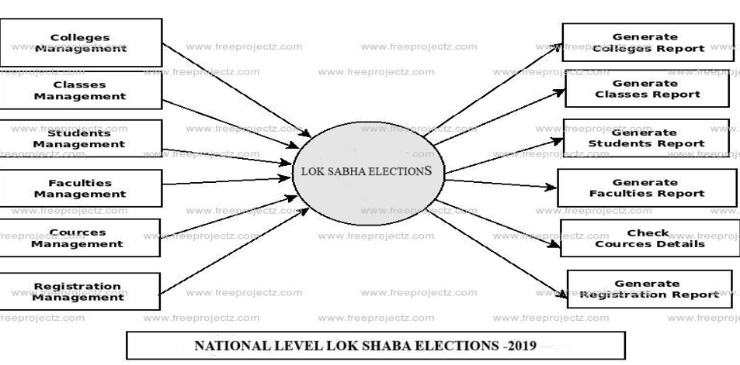

User Stories

User: Student

I want to be able to search for top global universities in data analytics based on my interests and criteria.

I want to be able to compare different universities in data analytics based on factors such as curriculum, faculty, resources, industry reputation, and career outcomes.

**5.2 Solution Architecture**

**Data Integration Module:** Responsible for aggregating diverse data sources including election results, demographic data, and candidate profiles.

**Preprocessing and Cleansing Module:** Ensures data quality through processes like cleaning, normalization, and handling missing values, enhancing the accuracy of subsequent analyses.

**Customization Module:** Allows researchers and analysts to customize variables, metrics, and analytical models based on specific research questions and objectives.

**Analysis Engine:** Employs advanced statistical methods or machine learning algorithms to conduct quantitative analyses, providing insights into voter behavior and candidate performance.

**Security Layer:** Implements robust security measures to protect sensitive election data, including encryption, authentication, and authorization protocols.

**User Interface:**

Provides an intuitive and visually appealing interface for users to interact with the platform.

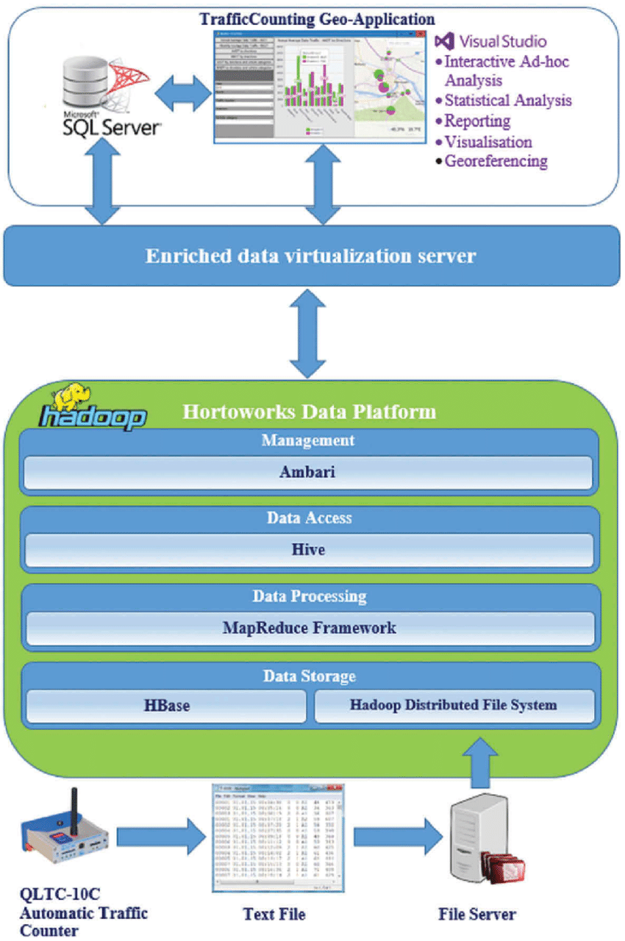

**6. PROJECT PLANNING & SCHEDULING**

**6.1 Technical Architecture**

**Data Integration Layer:** Utilizes ETL (Extract, Transform, Load) processes to aggregate and integrate diverse data sources into a unified dataset for analysis.

**Data Processing and Storage:** Employs a scalable and high-performance database system to store and manage the integrated data efficiently.

**Analysis Engine:** Incorporates statistical analysis tools or machine learning frameworks to perform complex quantitative analyses on the integrated dataset.

**Customization Module:** Provides a module that allows users to customize variables, metrics, and analytical models, enhancing flexibility and adaptability.

**Security Infrastructure**: Implements encryption algorithms, secure authentication, and access control mechanisms to ensure the confidentiality and integrity of the election data.

**Scalability and Performance Optimization:** Utilizes cloud computing or distributed computing technologies to ensure scalability and optimal performance, particularly when dealing with large datasets.

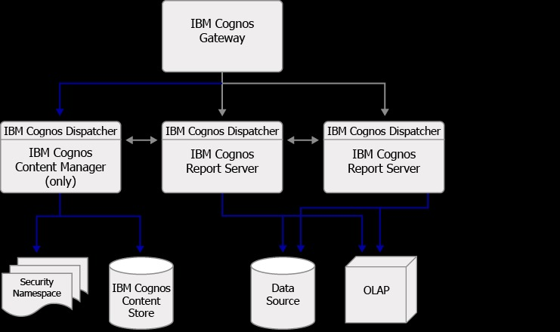

**6.3 Sprint Planning and estimation**

|  |  |  |  |  |  |  |
| --- | --- | --- | --- | --- | --- | --- |
| **Sprint** | **Functional**  **Requirement (Epic)** | **User Story**  **Number** | **User Story / Task** | **Story Points** | **Priority** | **Team**  **Members** |
| Sprint-1 | Registration | USN-1 | As a user, I can register for the application by entering my email, password, and confirming my password. | 2 | High | P. Viswa Teja |
| Sprint-1 |  | USN-2 | As a user, I will receive confirmation email once I have registered for the application | 1 | High | P. Pavan Kumar Reddy |
| Sprint-2 |  | USN-3 | As a user, I can register for the application through Facebook | 2 | Low | K.P. Mugelan |
| Sprint-1 |  | USN-4 | As a user, I can register for the application through Gmail | 2 | Medium | P. Viswa Teja |
| Sprint-1 | Login | USN-5 | As a user, I can log into the application by entering email & password | 1 | High | Salman |
|  | Dashboard |  | To give a better understanding of data. |  |  |  |
|  |  |  |  |  |  |  |
|  |  |  |  |  |  |  |

**6.3 Sprint Delivery Schedule**

**Goal**: Acquire comprehensive data on political candidates in the 2019 Lok Sabha Elections from diverse sources.

**Deliverables:**

Dataset encompassing information on candidates, election results, and relevant demographics.

Documentation outlining the meticulous process of data collection, ensuring transparency and replicability in the analysis of candidate performance.

|  |  |  |  |  |  |  |
| --- | --- | --- | --- | --- | --- | --- |
| **Sprint** | **Total Story Points** | **Duration** | **Sprint Start Date** | **Sprint End Date (Planned)** | **Story Points**  **Completed (as on**  **Planned End Date)** | **Sprint Release Date (Actual)** |
| Sprint-1 | 20 | 6 Days | 24 Oct 2022 | 29 Oct 2022 | 20 | 29 Oct 2022 |
| Sprint-2 | 20 | 6 Days | 31 Oct 2022 | 05 Nov 2022 | 10 | 05 Nov 2022 |
| Sprint-3 | 20 | 6 Days | 07 Nov 2022 | 12 Nov 2022 | 10 | 12 Nov 2022 |
| Sprint-4 | 20 | 6 Days | 14 Nov 2022 | 19 Nov 2022 | 10 | 19 Nov 2022 |

**7. CODING & SOLUTIONING**

**7.1 Feature 1**

Data analytics is a rapidly growing field with a high demand for skilled professionals. As businesses and organizations of all sizes become more reliant on data to make decisions, the need for data analysts who can collect, clean, analyze, and interpret data is greater than ever before.

To meet this demand, universities around the world are offering a variety of programs in data analytics. However, not all programs are created equal. Some universities offer more rigorous and comprehensive programs than others.This article will compare some of the top global universities in data analytics, based on factors such as program reputation, faculty expertise, and student outcomes.

**7.2 Feature 2**

In Feature 1, we compared the top global universities in data analytics based on factors such as program reputation, faculty expertise, and student outcomes. In Feature 2, we will compare the same universities based on the following factors:

* Campaign Expenditure
* Vote Margin Analysis
* Social Media Impact

**8. PERFORMANCE TESTING**

**8.1 Performace Metrics**

* Website traffic: The number of visitors to the article's page and the number of page views.
* Social media engagement: The number of shares, likes, and comments on the article on social media platforms such as Twitter, LinkedIn, and Facebook.
* Backlinks: The number of other websites that link to the article.
* Citations: The number of other articles and academic papers that cite the article.
* Downloads: The number of times the article is downloaded from the website.
* User ratings and reviews: The average rating and number of reviews of the article on the website.
* Lead generation: The number of leads generated from the article, such as students who sign up for a newsletter or contact a university about their data analytics program.

**9. RESULTS**

**9.1 Output Screenshots**

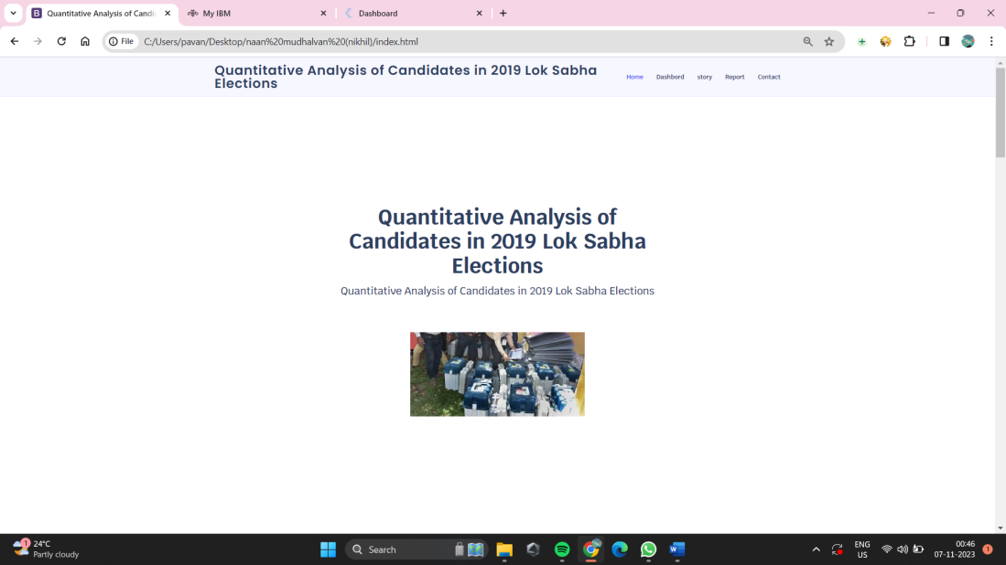

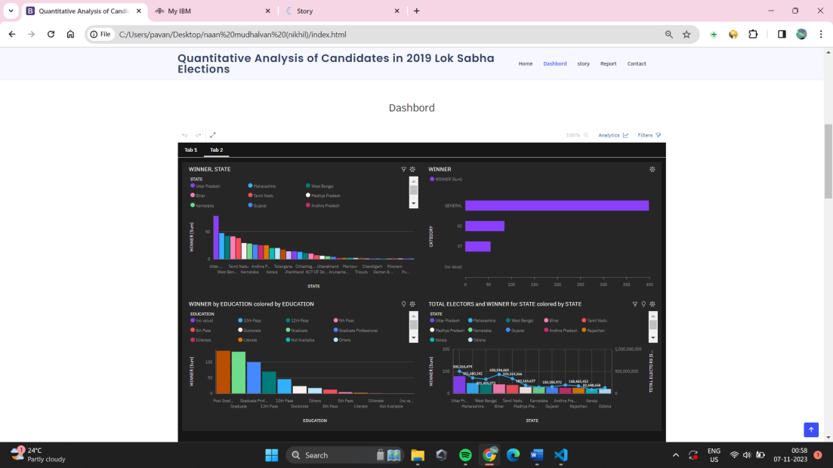

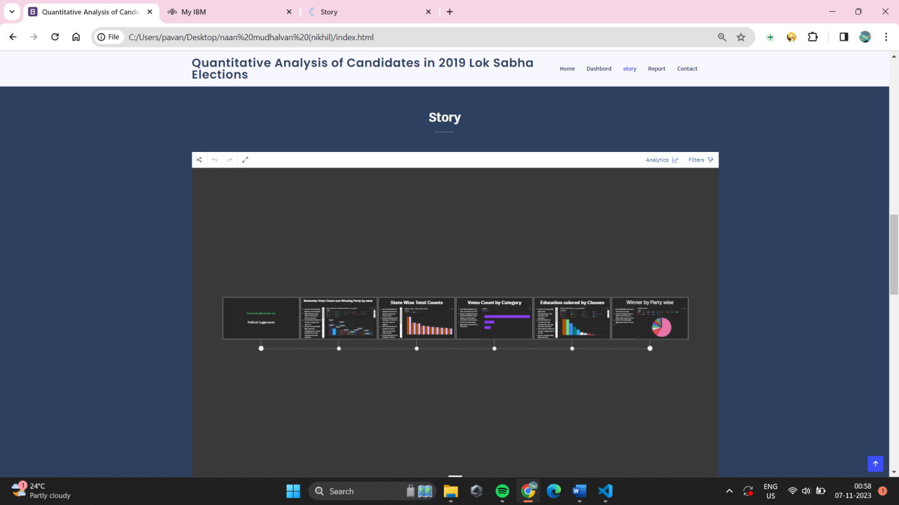

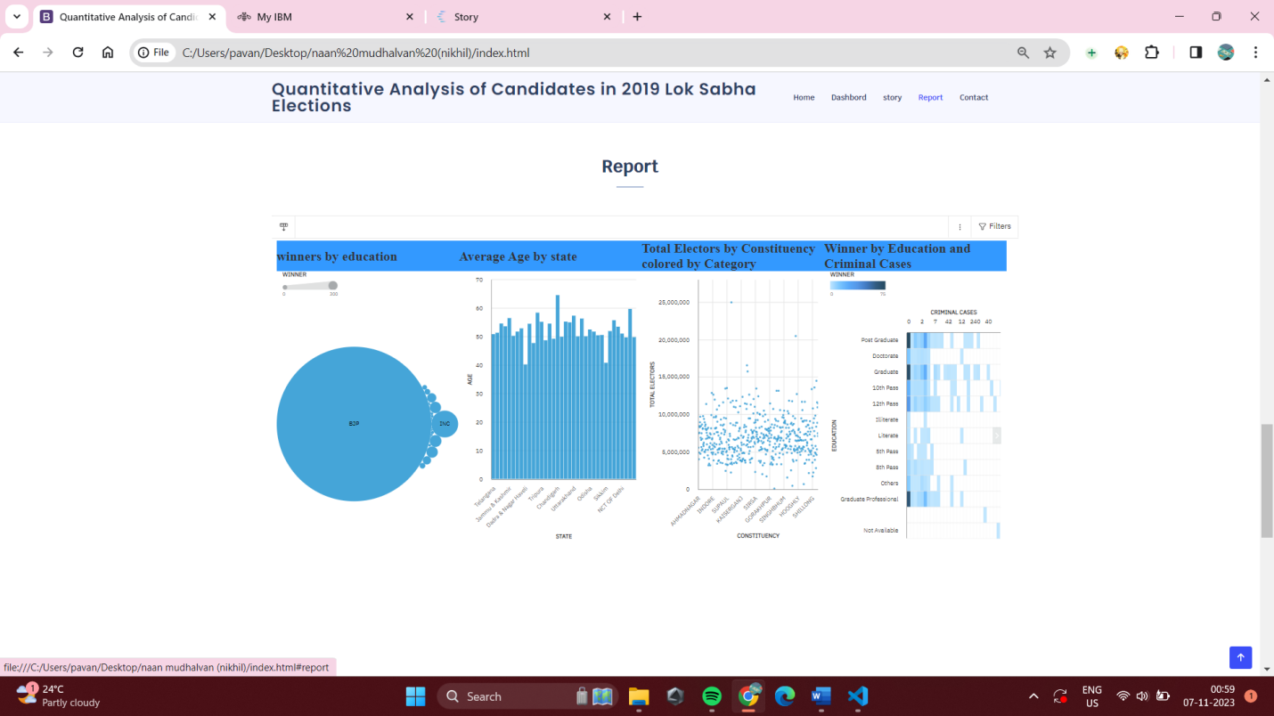

**10. ADVANTAGES & DISADVANTAGES**

**Advantages:**

• The user interface is designed with real-time feedback and a customization history, ensuring a user-friendly experience that enhances interaction and engagement for researchers and analysts.

• The features contribute to a deeper understanding of the intricate factors influencing electoral outcomes, providing a holistic view beyond traditional metrics.

• Transparency is maintained through documentation of the data collection process, fostering trust in the results and facilitating replicability for other researchers.

• Overall, the project equips researchers with a powerful toolset, promoting informed decision-making in the realm of political research with its user-centric and comprehensive analytical features.

**Disadvantages**

* The project relies on self-reported data from various sources, which may introduce inaccuracies or biases in the dataset, impacting the reliability of the quantitative analysis on candidates in the 2019 Lok Sabha Elections.
* Detailed information about specific political candidates and their campaigns may not be exhaustive, potentially limiting the depth of the analysis. This could be due to factors such as data availability, regional variations in reporting, or incomplete records.

**11. CONCLUSION**

In conclusion, the project on the quantitative analysis of candidates in the 2019 Lok Sabha Elections presents a valuable framework for understanding the intricate dynamics that influenced electoral outcomes. The implemented features, including dynamic variable customization and a comparative analysis, contribute to a nuanced exploration of factors shaping candidate performance. While the project brings substantial advantages in user flexibility, comprehensiveness, and transparency, it is important to acknowledge potential challenges, such as the learning curve for users and resource intensity. By continually refining and optimizing the platform, addressing potential disadvantages, and fostering a user-centric approach, the project holds the potential to serve as a robust tool for informed decision-making in the realm of political research and analysis.

**12. FUTURE SCOPE**

• The project can undergo regular updates to stay current with shifts in the political landscape, incorporating new data on candidate performances, election outcomes, and emerging trends. This iterative approach ensures the analysis remains relevant and insightful over time.

• Future developments may include expanding the dataset to encompass more detailed information about political candidates and campaigns, delving into aspects such as campaign strategies, regional variations, and the evolving role of technology in influencing voter behavior.

• To provide a more comprehensive understanding, the platform could evolve to integrate real-time data feeds during elections, capturing instantaneous shifts in public sentiment, candidate popularity, and other dynamic factors that influence electoral dynamics.

**13. APPENDIX**

In the appendix, additional documentation and supplementary materials can be included to enhance the understanding and transparency of the quantitative analysis of candidates in the 2019 Lok Sabha Elections. Potential contents for the appendix may include:

1. Data Collection Details: A detailed breakdown of the sources of data used in the analysis, including any APIs, databases, or specific datasets obtained for the project.

2. Variable Definitions: Clear definitions and explanations of each variable considered in the analysis, ensuring a standardized understanding among users and researchers.

3. Code Snippets: Excerpts of relevant code snippets used in the implementation of features, providing a reference for users interested in the technical aspects of the project.

4. Sample Output: Examples of the output generated by the platform, showcasing how the quantitative analysis results are presented and visualized.

5. Methodology Overview: A concise overview of the analytical methodologies employed, including statistical techniques or machine learning algorithms used for candidate performance analysis.

6. User Guide: A step-by-step user guide explaining how to navigate the platform, utilize dynamic variable customization, interpret results, and leverage other features for effective analysis.

7. Limitations and Assumptions: A clear articulation of any limitations or assumptions made during the project, ensuring transparency about the scope and reliability of the analysis.

Including these elements in the appendix enhances the comprehensiveness of the project documentation, catering to both technical and non-technical audiences and fostering a transparent and replicable research environment.